1. Write a shell script which will execute following set of tasks:

Please see the assignment.sh file attached

2. What is the difference between source and sh commands?

Source command is basically used to pass variable from one environment to another environment as we execute .sh file each shell has its own environment

By using sourcing we can put one .sh file in another .sh file to use the content and variable of the first file.

Source command can be used in two ways by using . and by typing source itself

3. Create two files “a.txt” and “b.txt”. Write a command to get the difference between the contents in two files.

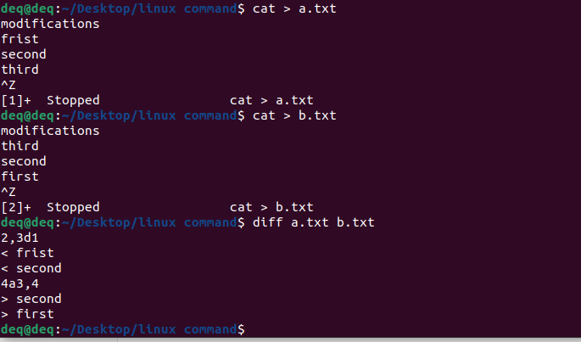

4. What is the difference between ls and lsof?

ls gives a list of directories and files present in a specific directory.

ls-R - gives whole files and folders present till the end from the current directory.

lsof gives us list files opened by which process, with the use of lsof we can find the list of files opened by a particular user.

lsof -R tells us files opened by a specific child process made while running a parent process.

5. Create directories ./hello/world (World dir is inside hello dir) using mkdir command where neither hello or world exists. It should be a single command without the use of &&.

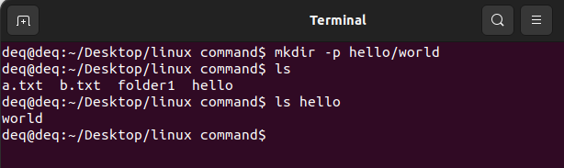

6. How can you permanently set an environment variable using a bash terminal?

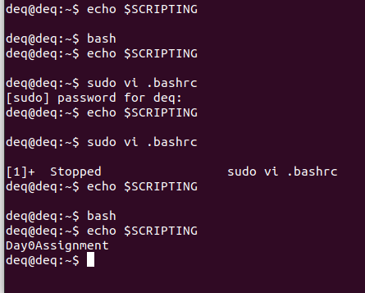

7. You have some process running on a port in your system. How can you view and then kill the process from the terminal?

Firstly created a python server by specifying port number



Listing all process running on port 3000

And killed the process using PID

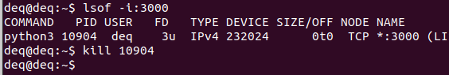

As we killed the process using PID the server got terminated

